HTML
PRACTICE EXERCISES
3 Hands-On Exercises with Visual Previews
Part of the Basic Web Development Series

Name: _________________________________ Date: _____________ Score: ______ / 30

How to Use This Workbook
These exercises are designed to be completed after reading the HTML Fundamentals guide. Each exercise asks you to build a real HTML page from scratch, matching the visual preview shown. Read the requirements carefully, write your code in a text editor (e.g. VS Code, Notepad++), save it as a .html file, and open it in your browser to check your work.

💡 | You only need a text editor and a web browser — no special software required. Create a new folder for each exercise and save your file as index.html.

Each exercise is worth 10 points. The scoring checklist at the bottom of each exercise tells you exactly what is being assessed.

Exercise 1 Personal Bio Page | ⏱ 20–30 min  ⭐ Beginner | Score  ____ / 10

Your Task
Build a personal bio page that introduces yourself. Your finished page should look like the preview below. You do not need to match it exactly — use your own name, hobbies, and details.

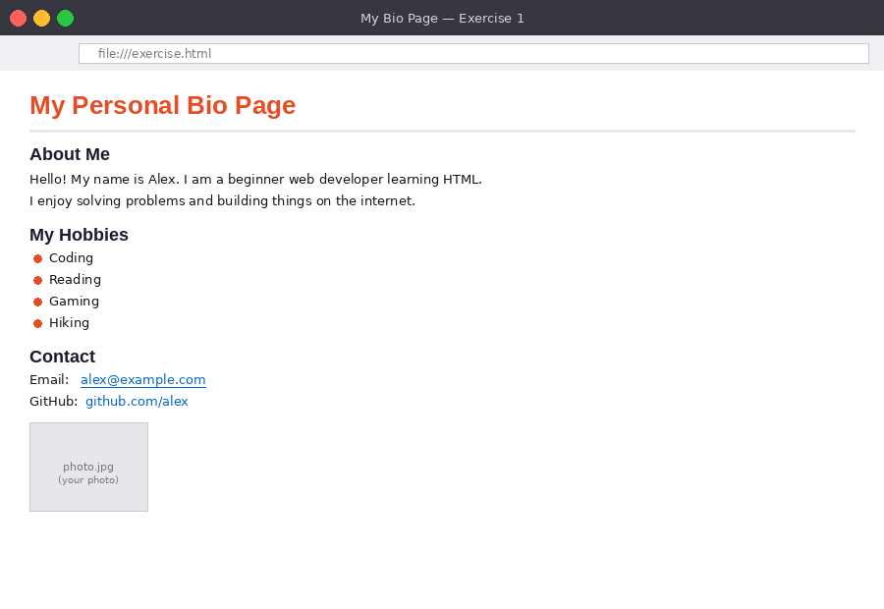
Figure 1: Example output for Exercise 1 — your page should have this structure and layout

Requirements
- Add a main page heading using an <h1> tag with your name or page title
- Add a horizontal rule <hr> below the heading
- Add an 'About Me' section using <h2> with a short paragraph <p> about yourself
- Add a 'My Hobbies' section using <h2> with an unordered list <ul> of at least 4 hobbies
- Add a 'Contact' section using <h2> with an email hyperlink using <a href='mailto:...'>
- Add a second hyperlink to any website (e.g. GitHub, LinkedIn)
- Add an image using <img> with a valid src and descriptive alt attribute

Starter Code
Begin with this skeleton in your text editor:
<!DOCTYPE html>
<html lang="en">
<head>
<meta charset="UTF-8">
<title>My Bio Page</title>
</head>
<body>

<!-- Your code goes here -->

</body>
</html>

Scoring Checklist
- ☐ <h1> heading present and contains your name or title (1 pt)
- ☐ <hr> horizontal rule appears below the heading (1 pt)
- ☐ 'About Me' <h2> section with at least one <p> paragraph (2 pts)
- ☐ 'My Hobbies' <h2> section with <ul> containing 4+ <li> items (2 pts)
- ☐ 'Contact' <h2> section with a mailto: hyperlink (2 pts)
- ☐ A second <a href> link to an external URL (1 pt)
- ☐ <img> with correct src and non-empty alt attribute (1 pt)

Exercise 2 Recipe Page with Table | ⏱ 30–45 min  ⭐⭐ Intermediate | Score  ____ / 10

Your Task
Create a recipe page for your favourite meal. It must include a structured ingredients list, numbered cooking instructions, and a nutrition information table.

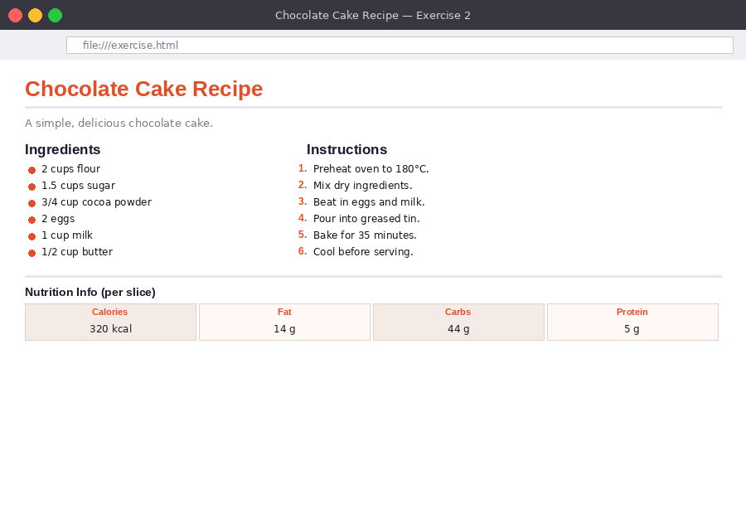
Figure 2: Example output for Exercise 2 — a recipe page with lists and a data table

Requirements
- A page title in <h1> with the recipe name
- A short description of the dish in a <p> tag below the title
- An 'Ingredients' section (<h2>) with an unordered list <ul> of at least 6 ingredients
- An 'Instructions' section (<h2>) with an ordered list <ol> of at least 5 steps
- A 'Nutrition Information' section (<h2>) with a <table> containing: a header row (<thead>, <th>) with at least 4 columns, and one data row (<tbody>, <td>) with values
- A horizontal rule <hr> separating the recipe from the nutrition table
- The page <title> in the <head> should match the recipe name

Hints
- Use <strong> inside a list item to bold an important ingredient, e.g. <strong>2 cups flour</strong>
- Remember: <th> creates bold header cells, <td> creates normal data cells
- Give your table a border attribute to make it visible: <table border='1'>

Scoring Checklist
- ☐ <h1> title and <p> description present (1 pt)
- ☐ Ingredients <ul> with 6+ items (2 pts)
- ☐ Instructions <ol> with 5+ numbered steps (2 pts)
- ☐ Table with <thead> and <th> header row (2 pts)
- ☐ Table <tbody> with at least one <tr> of <td> data (2 pts)
- ☐ <hr> separator and matching <title> in <head> (1 pt)

Exercise 3 Contact Form | ⏱ 40–60 min  ⭐⭐⭐ Advanced | Score  ____ / 10

Your Task
Build a fully functional contact form page. The form should collect a user's name, email, subject, message, and how they heard about the site. The form does not need to submit anywhere — focus on the HTML structure.

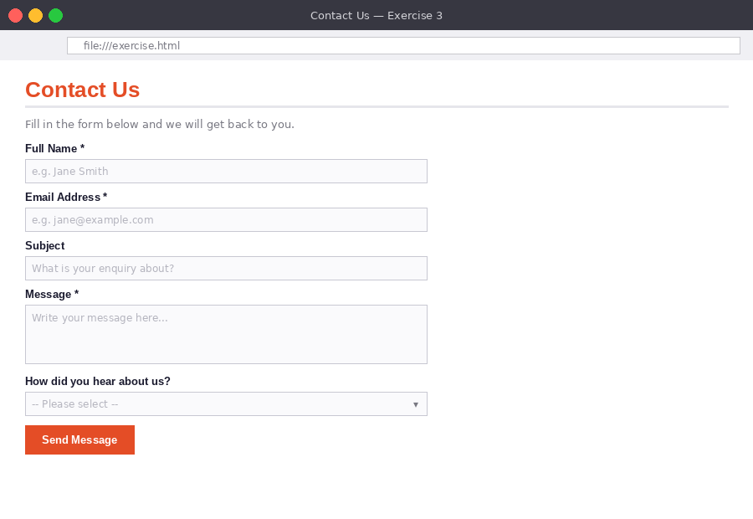
Figure 3: Example output for Exercise 3 — a contact form with labels, inputs, textarea, select, and submit button

Requirements
- A page heading <h1> — 'Contact Us' or similar
- A <p> description below the heading
- A <form> element with action="#" and method="post"
- A labelled text input for Full Name (use <label> and <input type='text'>) — mark as required
- A labelled email input for Email Address (<input type='email'>) — mark as required
- A labelled text input for Subject
- A labelled <textarea> for the message with rows='6'
- A <select> dropdown with at least 3 <option> choices for 'How did you hear about us?'
- A submit <button type='submit'>Send Message</button>

Hints
- Connect each <label> to its input using matching for and id attributes
- Use placeholder attributes on inputs to show hint text
- Add a <fieldset> and <legend> around the form inputs for bonus structure

Scoring Checklist
- ☐ Page <h1> and description <p> present (1 pt)
- ☐ <form> with action and method attributes (1 pt)
- ☐ Name and email inputs with correct type and required attribute (2 pts)
- ☐ Subject input and message <textarea> with rows attribute (2 pts)
- ☐ <label> tags correctly linked to inputs via for/id (2 pts)
- ☐ <select> dropdown with 3+ options (1 pt)
- ☐ Submit button present (1 pt)

When you have finished all three exercises, check your answers against the HTML Answer Sheet.

