HTML
BEGINNER MICRO-EXERCISES
One concept at a time — ideal for first-time coders
Complete alongside the HTML Fundamentals Guide

Name: _________________________________ Date: _____________ Total: ______ / 30

How to Use These Exercises
Each micro-exercise focuses on exactly one HTML concept. Complete them in order, one at a time, as you read through the HTML Fundamentals guide. The 📖 badge on each exercise tells you which section of the guide to read first.

💡 | All you need is a plain text editor (Notepad on Windows, TextEdit on Mac, or VS Code) and a web browser. Save each file as exercise1.html and open it in your browser to see the result.

Each exercise is worth 5 points and has a visual preview showing what your finished page should look like. You do not need to match it exactly — the structure matters more than the content.

Ex 1 Headings & Paragraphs | 📖 After Section 1 (HTML Basics)  ⭐ First Steps | ⏱  10 min | Score  __/5

What You Will Learn
How to create page headings at different sizes and write paragraphs of text. This is the foundation of every HTML page.

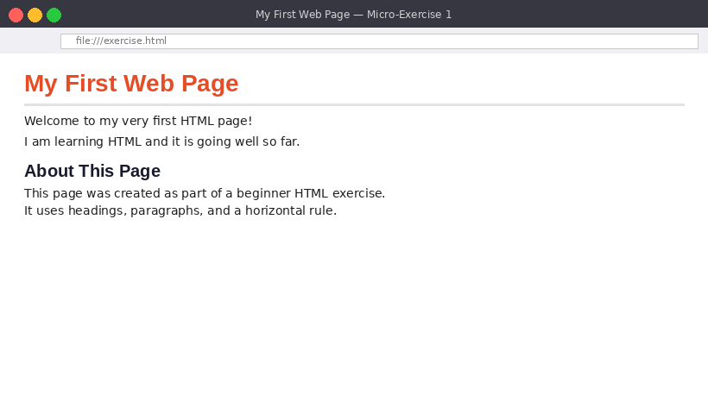
Figure 1.1 — Your finished page should have two headings, a rule, and two short paragraphs

Your Task
- Create a new file called exercise1.html and add the standard HTML skeleton (DOCTYPE, html, head, body)
- Give the page a <title> of 'My First Web Page' inside the <head>
- Inside the <body>, add an <h1> heading — write anything you like as the title
- Add a <hr> horizontal rule beneath the <h1>
- Add an <h2> heading below the rule (e.g. 'About This Page')
- Add at least two <p> paragraphs — one under the <h1>, one under the <h2>

Starter Skeleton

<!DOCTYPE html>
<html lang="en">
<head>
<meta charset="UTF-8">
<title>My First Web Page</title>
</head>
<body>

<!-- Your headings and paragraphs go here -->

</body>
</html>

Scoring Checklist
- ☐ HTML skeleton is complete and valid (DOCTYPE, html, head, body) — 1 pt
- ☐ <title> is set inside <head> — 1 pt
- ☐ <h1> heading present in the body — 1 pt
- ☐ <hr> appears on the page — 1 pt
- ☐ At least one <h2> and two <p> paragraphs present — 1 pt

Ex 2 Adding Images | 📖 After Section 2 (Tags & Elements)  ⭐ First Steps | ⏱  10 min | Score  __/5

What You Will Learn
How to embed images into an HTML page using the <img> tag, set a display size, and write descriptive alt text for accessibility.

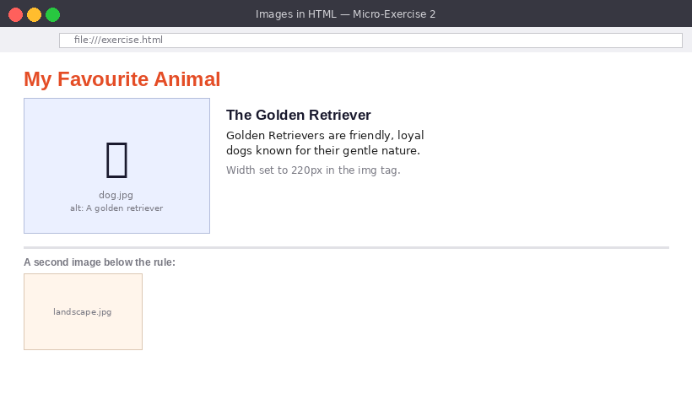
Figure 2.1 — Two images with alt text, a heading, and a short description beside the first image

Your Task
- Create exercise2.html with the full HTML skeleton
- Add an <h1> heading — e.g. 'My Favourite Animal'
- Find any image on your computer (or download one from the internet) and save it in the same folder as your HTML file
- Add an <img> tag pointing to that image — set the src to the filename and write a meaningful alt attribute describing the image
- Set the image width to 220 using the width attribute
- Add a <p> paragraph next to or below the image describing it
- Add a <hr> and then a second <img> below it (can be a different image or the same one)

Key Syntax

<!-- Basic image -->
<img src="dog.jpg" alt="A golden retriever sitting in the park" width="220">

<!-- If your image is in a subfolder called 'images' -->
<img src="images/dog.jpg" alt="A golden retriever" width="220">

💡 | The alt attribute is read aloud by screen readers for visually impaired users. Always describe what is actually in the image — not just its filename.

Scoring Checklist
- ☐ HTML skeleton complete — 1 pt
- ☐ First <img> tag present with a working src path — 1 pt
- ☐ alt attribute is non-empty and descriptive (not just the filename) — 1 pt
- ☐ width attribute sets the image size — 1 pt
- ☐ Second image appears below a <hr> — 1 pt

Ex 3 Unordered & Ordered Lists | 📖 After Section 3 (Lists)  ⭐ First Steps | ⏱  10 min | Score  __/5

What You Will Learn
How to create bullet-point lists (unordered) and numbered lists (ordered), and how to nest one list inside another.

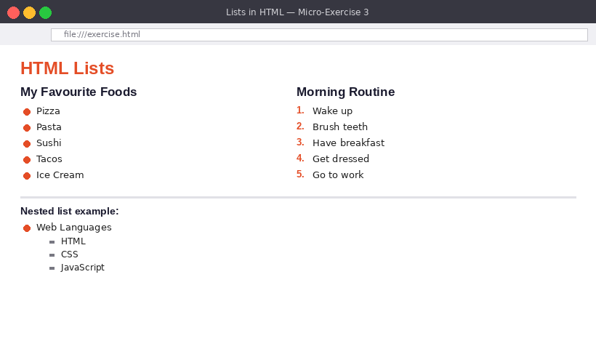
Figure 3.1 — Two lists side by side and a nested list below

Your Task
- Create exercise3.html with the full HTML skeleton
- Add an <h1> heading — e.g. 'HTML Lists'
- Create an <h2> — 'My Favourite Foods' — with an <ul> below it containing at least 5 items
- Create another <h2> — 'Morning Routine' — with an <ol> below it containing at least 5 steps
- Add an <h2> — 'Nested List' — then create a <ul> where at least one <li> contains a second <ul> inside it (see example below)

Nested List Example

<ul>
<li>Web Languages
<ul>
<li>HTML</li>
<li>CSS</li>
<li>JavaScript</li>
</ul>
</li>
<li>Backend Languages</li>
</ul>

Scoring Checklist
- ☐ <ul> with 5+ <li> items for the bullet list — 1 pt
- ☐ <ol> with 5+ <li> items for the numbered list — 1 pt
- ☐ Both lists have an <h2> heading above them — 1 pt
- ☐ Nested list with at least one inner <ul> inside an <li> — 1 pt
- ☐ All tags correctly opened and closed — 1 pt

Ex 4 Creating a Table | 📖 After Section 4 (Tables)  ⭐⭐ Getting There | ⏱  15 min | Score  __/5

What You Will Learn
How to build a data table with a header row, body rows, and multiple columns using <table>, <thead>, <tbody>, <th>, <tr>, and <td>.

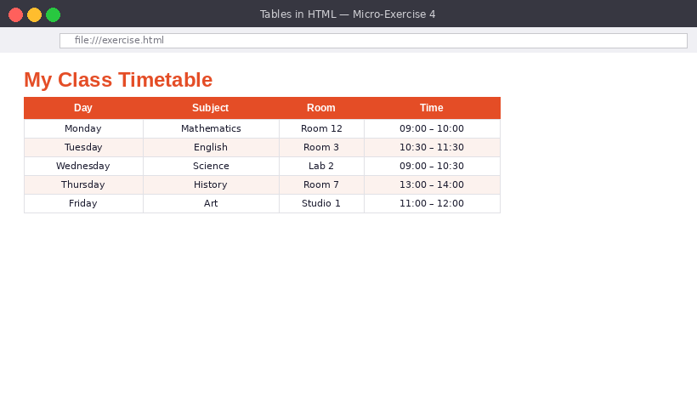
Figure 4.1 — A 4-column timetable with a styled header row and 5 data rows

Your Task
- Create exercise4.html with the full HTML skeleton
- Add an <h1> heading — e.g. 'My Class Timetable' or 'My Weekly Schedule'
- Create a <table> with the attribute border="1" so the grid lines are visible
- Inside the table, add a <thead> containing one <tr> with four <th> header cells: Day, Subject, Room, Time
- Add a <tbody> with at least 5 data rows, each with four <td> cells
- Make sure every row has the same number of cells as the header

Table Skeleton

<table border="1">
<thead>
<tr>
<th>Day</th>
<th>Subject</th>
<th>Room</th>
<th>Time</th>
</tr>
</thead>
<tbody>
<tr>
<td>Monday</td>
<td>Mathematics</td>
<td>Room 12</td>
<td>09:00 – 10:00</td>
</tr>
<!-- Add more rows here -->
</tbody>
</table>

Scoring Checklist
- ☐ <table> with border attribute wraps everything — 1 pt
- ☐ <thead> with a <tr> containing four <th> cells — 1 pt
- ☐ <tbody> present — 1 pt
- ☐ At least 5 data rows each with four <td> cells — 1 pt
- ☐ All rows have consistent column count — 1 pt

Ex 5 Hyperlinks | 📖 After Section 2 (Tags & Elements)  ⭐⭐ Getting There | ⏱  10 min | Score  __/5

What You Will Learn
How to create clickable links to other websites, email addresses, and sections within the same page using the <a> tag.

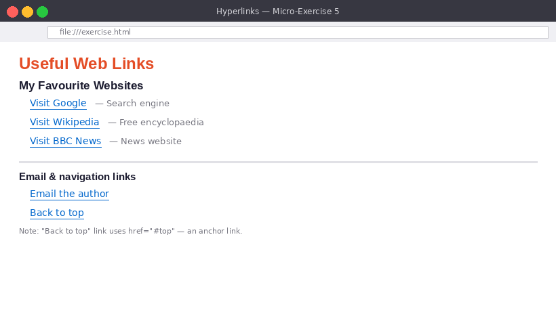
Figure 5.1 — External links, an email link, and an anchor (back to top) link

Your Task
- Create exercise5.html with the full HTML skeleton
- Add an <h1> — e.g. 'Useful Web Links'
- Create an <h2> — 'My Favourite Websites' — then an unordered list with at least 3 external links, each opening in a new tab (use target="_blank")
- Add a <hr> then an <h2> — 'Get in Touch' — with an email link using mailto:
- At the very top of the body, add id="top" to the <h1>. At the bottom of the page, add a link with href="#top" that says 'Back to top'

Key Syntax

<!-- External link — opens in new tab -->
<a href="https://www.bbc.co.uk" target="_blank">Visit BBC</a>

<!-- Email link -->
<a href="mailto:hello@example.com">Email me</a>

<!-- Anchor link (same page) -->
<h1 id="top">My Page</h1>
<!-- ... lots of content ... -->
<a href="#top">Back to top</a>

Scoring Checklist
- ☐ 3+ external links each with href starting https:// — 1 pt
- ☐ All external links use target="_blank" — 1 pt
- ☐ Email link uses mailto: correctly — 1 pt
- ☐ id="top" on the <h1> and anchor link href="#top" at bottom — 1 pt
- ☐ Links are inside a list or clearly structured with headings — 1 pt

Ex 6 Semantic Page Layout | 📖 After Section 6 (Semantic HTML)  ⭐⭐ Getting There | ⏱  20 min | Score  __/5

What You Will Learn
How to structure a complete webpage using meaningful semantic tags — <header>, <nav>, <main>, <article>, <aside>, and <footer> — instead of generic <div> tags.

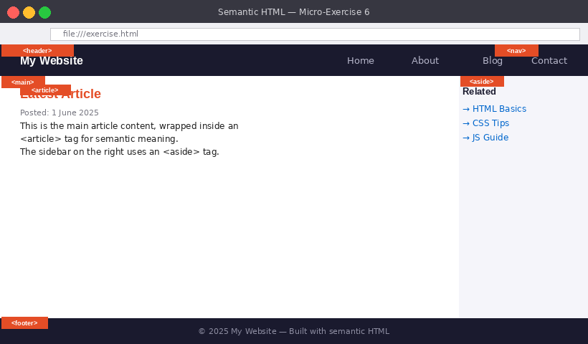
Figure 6.1 — A labelled semantic page with header, nav, main, article, aside, and footer all clearly identified

Your Task
- Create exercise6.html with the full HTML skeleton
- Inside <body>, add a <header> containing your site name in an <h1> and a <nav> with an unordered list of 4 navigation links (href="#" is fine)
- Below the header, add a <main> element containing two child elements side by side in structure: an <article> with a heading and two paragraphs, and an <aside> with a heading and a short list of related links
- Below <main>, add a <footer> with a copyright line — e.g. © 2025 My Website
- Add an HTML comment above each semantic tag explaining what it is — e.g. <!-- Site header -->

Page Structure

<body>
<!-- Site header with navigation -->
<header>
<h1>My Website</h1>
<nav>
<ul>
<li><a href="#">Home</a></li>
<!-- add more links -->
</ul>
</nav>
</header>

<!-- Main page content -->
<main>
<article>
<!-- Article content here -->
</article>
<aside>
<!-- Sidebar content here -->
</aside>
</main>

<!-- Site footer -->
<footer>
<p>&copy; 2025 My Website</p>
</footer>
</body>

Scoring Checklist
- ☐ <header> contains a site name heading and a <nav> with links — 1 pt
- ☐ <main> wraps the primary content — 1 pt
- ☐ <article> with heading and paragraphs inside <main> — 1 pt
- ☐ <aside> with a heading and links inside <main> — 1 pt
- ☐ <footer> with copyright text and HTML comments on each section — 1 pt

Well done for completing all 6 micro-exercises! You are now ready to tackle the full HTML Exercises workbook.

