BASIC WEB DEVELOPMENT SERIES
HTML
PRACTICE EXERCISES
3 Hands-On Exercises with Visual Previews
Complete after the HTML Fundamentals Guide

Name: _______________________ Date: ___________ Score: ______ / 30

How to Use This Workbook
Complete these exercises after reading the HTML Fundamentals guide. Each exercise asks you to build a real HTML page from scratch, matching the visual preview shown. Save your file as index.html and open it in your browser to check your work.
TIP | All you need is a text editor (VS Code, Notepad, or TextEdit) and a web browser. No special software required.

Ex 1 Personal Bio Page | 📖 After Section 1-2  Beginner | ⏱  20-30 min | Score  __ / 10

Your Task
Build a personal bio page introducing yourself. Your page should have this structure and layout:
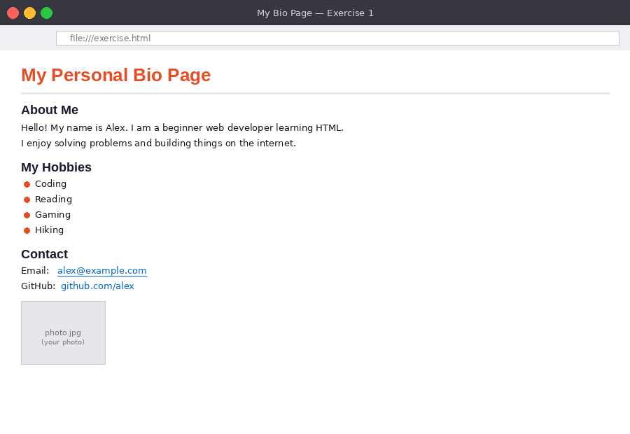
Figure 1 - Example output: heading, rule, about section, hobby list, contact links, and an image
Requirements
- Add a main <h1> heading with your name or page title
- Add a <hr> horizontal rule below the heading
- Add an 'About Me' <h2> section with a short <p> paragraph about yourself
- Add a 'My Hobbies' <h2> section with an unordered list of at least 4 hobbies
- Add a 'Contact' <h2> section with an email hyperlink using mailto:
- Add a second hyperlink to any website (e.g. GitHub, LinkedIn)
- Add an <img> with a valid src and descriptive alt attribute
Starter Code
<!DOCTYPE html>
<html lang="en">
<head>
<meta charset="UTF-8">
<title>My Bio Page</title>
</head>
<body>
<!-- Your code goes here -->
</body>
</html>

Scoring Checklist
- ☐ <h1> heading present (1 pt)
- ☐ <hr> appears below the heading (1 pt)
- ☐ 'About Me' <h2> with at least one <p> paragraph (2 pts)
- ☐ 'My Hobbies' <h2> with <ul> containing 4+ <li> items (2 pts)
- ☐ 'Contact' <h2> with a mailto: hyperlink (2 pts)
- ☐ A second <a href> link to an external URL (1 pt)
- ☐ <img> with correct src and non-empty alt attribute (1 pt)

Ex 2 Recipe Page with Table | 📖 After Section 3-4  Intermediate | ⏱  30-45 min | Score  __ / 10

Your Task
Create a recipe page for your favourite meal with a structured ingredients list, numbered instructions, and a nutrition table.
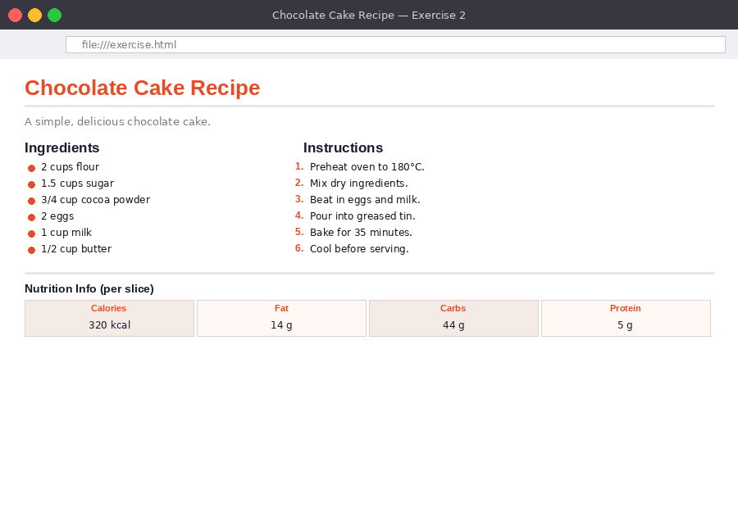
Figure 2 - Example output: recipe page with lists and a nutrition data table
Requirements
- A page title <h1> with the recipe name
- A short description <p> below the title
- An 'Ingredients' <h2> with an unordered <ul> of at least 6 ingredients
- An 'Instructions' <h2> with an ordered <ol> of at least 5 steps
- A 'Nutrition' <h2> with a <table> containing a <thead> header row and one <tbody> data row
- A <hr> separating the recipe from the nutrition table
- The page <title> in the <head> should match the recipe name
Scoring Checklist
- ☐ <h1> title and <p> description present (1 pt)
- ☐ Ingredients <ul> with 6+ items (2 pts)
- ☐ Instructions <ol> with 5+ numbered steps (2 pts)
- ☐ Table with <thead> and <th> header row (2 pts)
- ☐ Table <tbody> with at least one <tr> of <td> data (2 pts)
- ☐ <hr> separator and matching <title> in <head> (1 pt)

Ex 3 Contact Form | 📖 After Section 5  Advanced | ⏱  40-60 min | Score  __ / 10

Your Task
Build a fully functional contact form. The form collects name, email, subject, message, and how the user heard about the site. Focus on HTML structure.
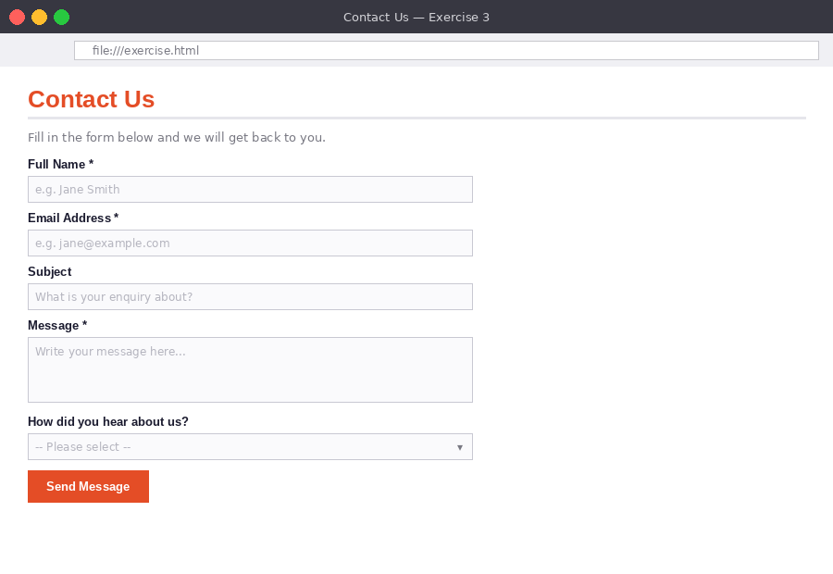
Figure 3 - Example output: contact form with labels, inputs, textarea, select, and submit button
Requirements
- A <h1> heading and a <p> description
- A <form> element with action="#" and method="post"
- A labelled text input for Full Name - mark as required
- A labelled email input - mark as required
- A labelled text input for Subject
- A labelled <textarea> for message with rows='6'
- A <select> dropdown with at least 3 <option> choices
- A <button type='submit'>Send Message</button>
Scoring Checklist
- ☐ Page <h1> and description <p> present (1 pt)
- ☐ <form> with action and method attributes (1 pt)
- ☐ Name and email inputs with correct type and required (2 pts)
- ☐ Subject input and <textarea> with rows attribute (2 pts)
- ☐ <label> tags correctly linked to inputs via for/id (2 pts)
- ☐ <select> dropdown with 3+ options (1 pt)
- ☐ Submit button present (1 pt)

Check your answers against the HTML Answer Sheet when finished.

