BASIC WEB DEVELOPMENT SERIES
HTML
BEGINNER MICRO-EXERCISES
One concept at a time - ideal for first-time coders
Complete alongside the HTML Fundamentals Guide

Name: _______________________ Date: ___________ Total: ______ / 30

How to Use These Exercises
Each micro-exercise focuses on exactly one HTML concept. Complete them in order as you read through the HTML Fundamentals guide. The 'After Section' badge on each exercise tells you which section to read first.
TIP | All you need is a text editor and a web browser. Save each file as exercise1.html and open it in your browser to see the result.

Ex 1 Headings and Paragraphs | 📖 After Section 1  First Steps | ⏱  10 min | Score  __ / 5

What You Will Learn
How to create page headings at different sizes and write paragraphs of text.
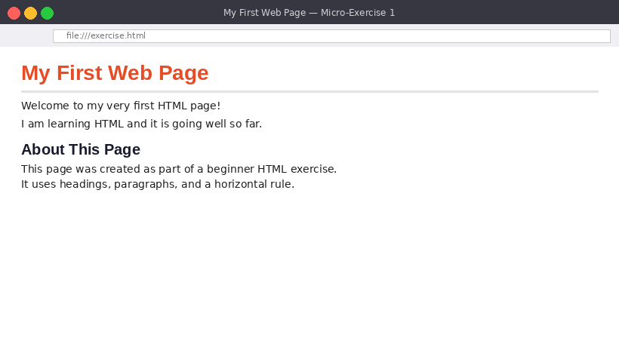
Figure 1.1 - Two headings, a horizontal rule, and two paragraphs
Your Task
- Create exercise1.html with the full HTML skeleton (DOCTYPE, html, head, body)
- Give the page a <title> of 'My First Web Page' in the <head>
- Add an <h1> heading inside the <body>
- Add a <hr> horizontal rule beneath the <h1>
- Add an <h2> heading below the rule
- Add at least two <p> paragraphs
Key Syntax / Starter Code
<!DOCTYPE html>
<html lang="en">
<head>
<meta charset="UTF-8">
<title>My First Web Page</title>
</head>
<body>

<!-- Your code goes here -->

</body>
</html>

Scoring Checklist
- ☐ Full HTML skeleton present and valid - 1 pt
- ☐ <title> set inside <head> - 1 pt
- ☐ <h1> heading in the body - 1 pt
- ☐ <hr> on the page - 1 pt
- ☐ At least one <h2> and two <p> tags - 1 pt

Ex 2 Adding Images | 📖 After Section 2  First Steps | ⏱  10 min | Score  __ / 5

What You Will Learn
How to embed images using <img>, set display size, and write descriptive alt text.
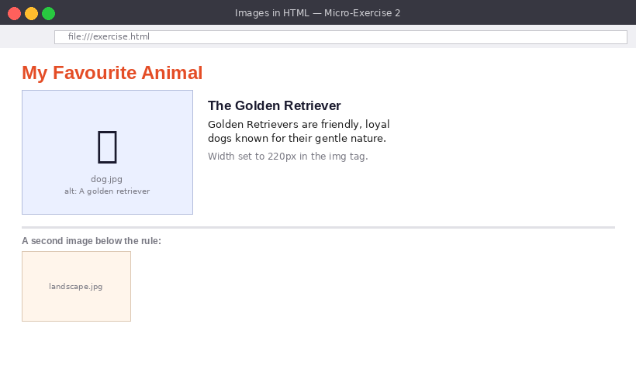
Figure 2.1 - Two images with alt text, a heading, and a short description
Your Task
- Create exercise2.html with the full HTML skeleton
- Add an <h1> heading - e.g. 'My Favourite Animal'
- Save an image file in the same folder as your HTML file
- Add an <img> tag with src pointing to the image and a meaningful alt attribute
- Set the image width to 220 using the width attribute
- Add a <p> describing the image
- Add a <hr> and a second <img> below it
Key Syntax / Starter Code
<!-- Basic image -->
<img src="dog.jpg" alt="A golden retriever sitting in the park" width="220">

<!-- Image in subfolder -->
<img src="images/dog.jpg" alt="A golden retriever" width="220">

Scoring Checklist
- ☐ HTML skeleton complete - 1 pt
- ☐ First <img> with a working src path - 1 pt
- ☐ alt attribute is descriptive (not just a filename) - 1 pt
- ☐ width attribute sets image size - 1 pt
- ☐ Second image appears below a <hr> - 1 pt

Ex 3 Unordered and Ordered Lists | 📖 After Section 3  First Steps | ⏱  10 min | Score  __ / 5

What You Will Learn
How to create bullet-point lists (unordered) and numbered lists (ordered), and nest them.
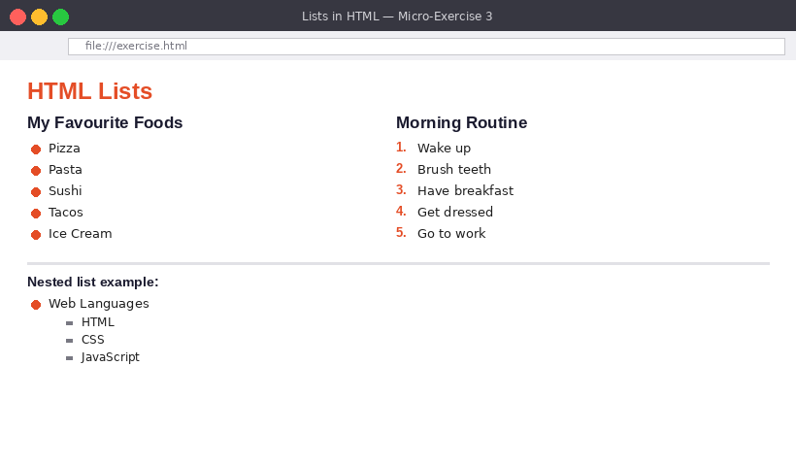
Figure 3.1 - Two lists side by side and a nested list below
Your Task
- Create exercise3.html with the full HTML skeleton
- Add an <h1> heading - e.g. 'HTML Lists'
- Create an <h2> 'My Favourite Foods' with a <ul> of at least 5 items
- Create an <h2> 'Morning Routine' with an <ol> of at least 5 steps
- Create an <h2> 'Nested List' with a <ul> where one <li> contains a second <ul>
Key Syntax / Starter Code
<ul>
<li>Web Languages
<ul>
<li>HTML</li>
<li>CSS</li>
<li>JavaScript</li>
</ul>
</li>
<li>Backend</li>
</ul>

Scoring Checklist
- ☐ <ul> with 5+ <li> items - 1 pt
- ☐ <ol> with 5+ <li> items - 1 pt
- ☐ Both lists have an <h2> heading above them - 1 pt
- ☐ Nested list with an inner <ul> inside an <li> - 1 pt
- ☐ All tags correctly opened and closed - 1 pt

Ex 4 Creating a Table | 📖 After Section 4  Getting There | ⏱  15 min | Score  __ / 5

What You Will Learn
How to build a data table with a header row and body rows using table, thead, tbody, th, tr, and td.
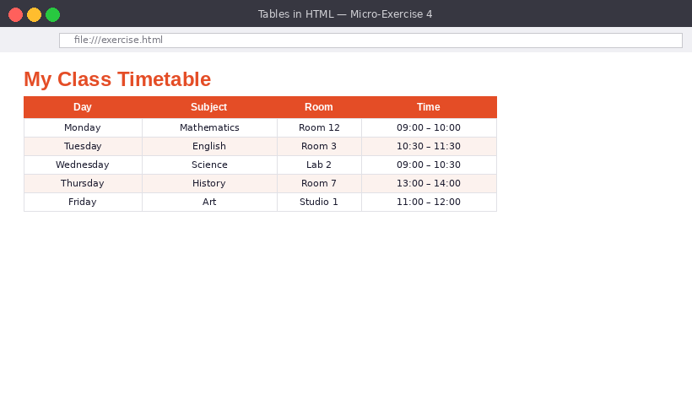
Figure 4.1 - A 4-column timetable with a header row and 5 data rows
Your Task
- Create exercise4.html with the full HTML skeleton
- Add an <h1> - e.g. 'My Class Timetable'
- Create a <table> with border="1" so grid lines are visible
- Add a <thead> with one <tr> containing four <th> cells: Day, Subject, Room, Time
- Add a <tbody> with at least 5 data rows, each with four <td> cells
- Make sure every row has the same number of cells as the header
Key Syntax / Starter Code
<table border="1">
<thead>
<tr>
<th>Day</th>
<th>Subject</th>
<th>Room</th>
<th>Time</th>
</tr>
</thead>
<tbody>
<tr>
<td>Monday</td>
<td>Maths</td>
<td>Room 12</td>
<td>09:00 - 10:00</td>
</tr>
<!-- Add more rows here -->
</tbody>
</table>

Scoring Checklist
- ☐ <table border='1'> wraps everything - 1 pt
- ☐ <thead> with a <tr> and four <th> cells - 1 pt
- ☐ <tbody> present - 1 pt
- ☐ 5+ data rows each with four <td> cells - 1 pt
- ☐ All rows have consistent column count - 1 pt

Ex 5 Hyperlinks | 📖 After Section 2  Getting There | ⏱  10 min | Score  __ / 5

What You Will Learn
How to create clickable links to websites, email addresses, and sections within the same page.
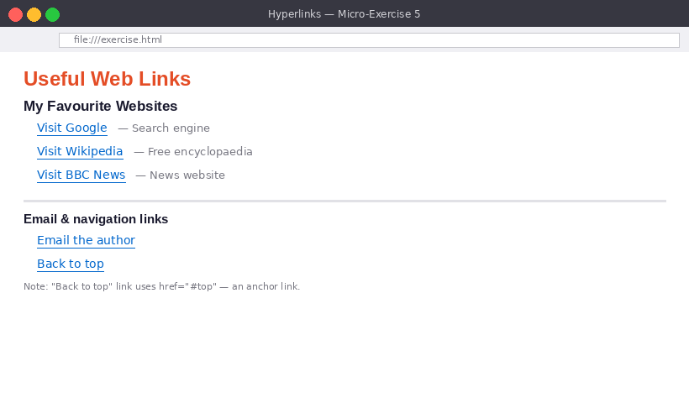
Figure 5.1 - External links, an email link, and a 'back to top' anchor link
Your Task
- Create exercise5.html with the full HTML skeleton
- Add an <h1 id='top'> at the top of the body
- Create an <h2> with at least 3 external links in a <ul>, each opening in a new tab
- Add a <hr> then an <h2> with an email link using mailto:
- At the bottom of the page add a link with href='#top' that reads 'Back to top'
Key Syntax / Starter Code
<!-- External link -->
<a href="https://www.bbc.co.uk" target="_blank">Visit BBC</a>

<!-- Email link -->
<a href="mailto:hello@example.com">Email me</a>

<!-- Anchor link -->
<h1 id="top">My Page</h1>
<!-- ... content ... -->
<a href="#top">Back to top</a>

Scoring Checklist
- ☐ 3+ external links each with href starting https:// - 1 pt
- ☐ All external links use target='_blank' - 1 pt
- ☐ Email link uses mailto: correctly - 1 pt
- ☐ id='top' on <h1> and href='#top' at bottom - 1 pt
- ☐ Links are structured with headings - 1 pt

Ex 6 Semantic Page Layout | 📖 After Section 6  Getting There | ⏱  20 min | Score  __ / 5

What You Will Learn
How to structure a full page with header, nav, main, article, aside, and footer instead of generic divs.
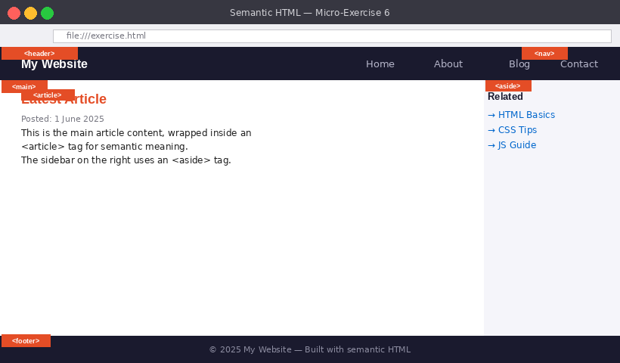
Figure 6.1 - A labelled semantic page with all major structural tags identified
Your Task
- Create exercise6.html with the full HTML skeleton
- Add a <header> with your site name in an <h1> and a <nav> with a list of 4 links
- Add a <main> containing an <article> with a heading and two paragraphs
- Inside <main> also add an <aside> with a heading and a short list of links
- Add a <footer> with a copyright line
- Add an HTML comment above each semantic tag explaining what it is
Key Syntax / Starter Code
<body>
<!-- Site header -->
<header>
<h1>My Website</h1>
<nav><ul><li><a href="#">Home</a></li></ul></nav>
</header>

<!-- Main content -->
<main>
<article>
<!-- Article content -->
</article>
<aside>
<!-- Sidebar -->
</aside>
</main>

<!-- Footer -->
<footer>
<p>&copy; 2025 My Website</p>
</footer>
</body>

Scoring Checklist
- ☐ <header> with site name and <nav> with links - 1 pt
- ☐ <main> wraps the primary content - 1 pt
- ☐ <article> with heading and paragraphs inside <main> - 1 pt
- ☐ <aside> with heading and links inside <main> - 1 pt
- ☐ <footer> with copyright and HTML comments on each section - 1 pt

Well done! You are now ready for the full HTML Exercises workbook.

